Feb 24, 2013

Team 19: Robot Control Specification Document

**Laboratory # 2: Requirements and Specification**

**Morgan, Laura**

**Miaw, Jireh**

**Hauser, Steven**

**Dworak, Catherine**

**Bertoglio, David**

***Work Product***

**The Specification Document describes the behavior of the robot control system. It includes the glossary, mode definition, mode transition table, conditions, input and output data items, and event table.**

***Document Revision Information***

**Document Revision Information**

2/10/2013 – Template created

2/15/2013 – Mode definitions and events

2/18/2013 – Input and output data items

2/22/2013 – Glossary and event table

2/24/2013 - Completed

**Approval Sheet**

**All group members whose names are listed below approve of the document and contributed fairly.**

**Morgan, Laura**

**Miaw, Jireh**

**Hauser, Steven**

**Dworak, Catherine**

**Bertoglio, David**

**Pledge**

**On my honor, as a student, I have neither given nor received unauthorized aid on this assignment.**

**Morgan, Laura**

**Miaw, Jireh**

**Hauser, Steven**

**Dworak, Catherine**

**Bertoglio, David**

Table of Contents

Glossary 4

Text Macros 4

Input Data Items 4

Output Data Items 5

Conditions 5

Set of Modes 6

Mode Transition Table 6

Define User Interface 7

Inputs and Outputs 7

Inputs 7

Outputs 9

Define Set of Events 10

Glossary  
  
Symbolic Constants

|  |  |  |
| --- | --- | --- |
| Name | Definition | Value |
| $max_speed$ | max speed of motors | TO BE DETERMINED |
| $NoOp$ | no operation is taken by GUI | Null |
| $pressed$ | button on GUI is pressed down | True |
| $released$ | butoon on GUI was pressed and has been released | True |
| $arc_radius$ | radius of arc taken by robot when multiple buttons pressed | TO BE DETERMINED |

## Text Macros

|  |  |
| --- | --- |
| Name | Definition |
| !connection! | connection between the robot and base station |
| !error_message_table! | listing of all error messages to error code |
| !reading! | decoded /input_message/ to be displayed |
| !response! | message sent from robot to base station |

### Input Data Items

|  |  |
| --- | --- |
| Name | Definition |
| /button_backwad/ | controls backward movement |
| /button_forward/ | controls forward movment |
| /button_left/ | controls movement left |
| /button_right/ | controls  movement right |
| /button_sensor_light/ | displays light sensor information |
| /button_sensor_unltrasonic/ | displays ultrasonic sensor information |
| /input_speed/ | input for new speed |
| /button_get_connection/ | get connection |
| /button_end_connection/ | end connection |
| /button_change_speed/ | changes speed of robot |
| /input_message/ | message received from robot |

### Output Data Items

|  |  |
| --- | --- |
| Name | Definition |
| //data_log// | display for messages from robot |
| //sensor_light// | display for light sensor |
| //sensor_touch// | display for touch sensor |
| //sensor_sound// | display for sound sensor |
| //sensor_ultrasonic// | display for ultrasonic sensor |
| //output message// | message sent to robot |

## Conditions

|  |  |
| --- | --- |
| Name | Definition |
| %connection_received% | Whether a connection is created or not. |
| %get_connection% | /button_get_connection/ = $released$ |
| %message_recieved% | A message |
| %time_out% | 10 seconds no response |
| %connected% | !connection! = True |
| %end_connection% | /button_end_connection/ = $released$ |
| %is_error_message% | Whether /input_message/ is error |

# Set of Modes

|  |  |
| --- | --- |
| Name | Definition |
| *Normal Operation* | %connected% |
| *Awaiting Connection* | !connection! = false /button_get_connection/ = $pressed$ |
| *No Connection* | !connection! = false |

# Mode Transition Table

|  |  |  |  |
| --- | --- | --- | --- |
|  | *Normal Operation* | *Awaiting Connection* | *No Connection* |
| *Normal Operation* |  | @T(%connection_received%) | @T(%end_connection%) |
| *Awaiting Connection* | @T(%connection_received) |  | @T(%time_out%) |
| *No Connection* |  | @T(%get_connection%) |  |

Define User Interface

Figure 1. Robot GUI  
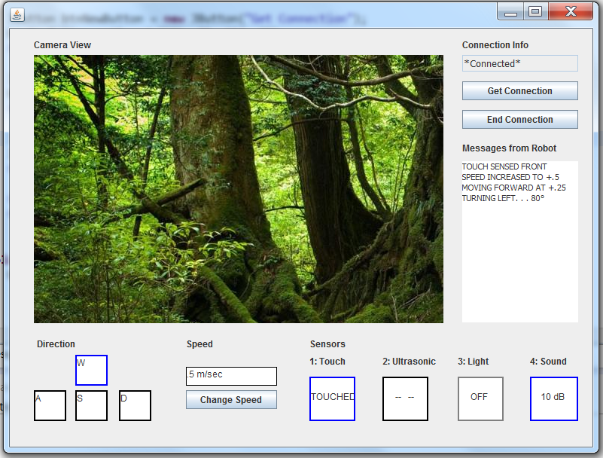

Inputs and Outputs

Inputs  
  
Input data item:  Forward push button  
Acronym: /button_forward/  
Hardware:  Switch, normally open  
Description: /button_forward/  
            - controls forward movement

- while pressed move forward, when released stop

Input data item:  Backward push button  
Acronym: /button_backward/  
Hardware:  Switch, normally open  
Description: /button_backward/  
            - controls backwards movement

- while pressed move backward, when released stop

Input data item:  Right push button  
Acronym: /button_right/  
Hardware:  Switch, normally open  
Description: /button_right/  
            - controls movement right          
  
Input data item:  Left push button  
Acronym: /button_left/  
Hardware:  Switch, normally open  
Description: /button_left/  
            - controls movement left            
  
Input data item:  Light sensor button  
Acronym: /button_sensor_light/  
Hardware:  Switch, normally open  
Description: /button_sensor_light/  
            -data from light sensor will be displayed in light sensor display  
  
Input data item:  Ultrasonic sensor button  
Acronym: /button_sensor_ultrasonic/  
Hardware:  Switch, normally open  
Description: /button_sensor_ultrasonic/  
            -data from ultrasonic sensor will be displayed in ultrasonic sensor display  
  
Input data item:  Speed input  
Acronym: /input_speed/  
Hardware:  Switch, normally open  
Description: /input_speed/  
            -receive keyboard input of numbers to change speed  
  
Input data item:  Change speed button  
Acronym: /button_change_speed/  
Hardware:  Momentary switch, normally open  
Description: /button_change_speed/  
            -change robot speed to speed currently in /input_speed/  
Data Representation:

Byte 3 is Motor/Motor combinations

Bytes 4-9 is the new speed

Input data item:  Get connection button  
Acronym: /button_get_connection/  
Hardware:  Momentary switch, normally open  
Description: /button_get_connection/  
            -transitions from *No Connection* to *Awaiting Connection*  
  
Input data item:  End connection button  
Acronym: /button_end_connection/  
Hardware:  Momentary switch, normally open  
Description: /button_end_connection/  
            -transitions from *Normal Operation* to *No Connection*  
  
Input data item:  Message received from robot  
Acronym: /input_message/  
Hardware:  Communications link (bluetooth)  
Description: /input_message/  
            -message sent from the robot

Outputs  
  
Output data item: Message sent to the robot  
Acronym: //output_message//  
Hardware: Communications link (bluetooth)  
Description: //output_message//  
 - encodes commands for the robot to complete based on user input  
Characteristic of values: encoded based on communication specification; 10 character message  
  
Output data item: Light sensor output  
Acronym: //sensor_light//  
Hardware: LCD monitor  
Description: //sensor_light//  
 - display most recently read value from light sensor  
Characteristic of values: Strings  
  
Output data item: Sound sensor output  
Acronym: //sensor_sound//  
Hardware: LCD monitor  
Description: //sensor_sound//  
 - display most recently read value from sound sensor  
Characteristic of values: Strings  
  
Output data item: Touch sensor output  
Acronym: //sensor_touch//  
Hardware: LCD monitor  
Description: //sensor_touch//  
 - display most recently read value from touch sensor  
Characteristic of values: Strings  
  
Output data item: Ultrasonic sensor output  
Acronym: //sensor_ultrasonic//  
Hardware: LCD monitor  
Description: //sensor_ultasonic//  
 - display most recently read value from ultrasonic sensor  
Characteristic of values: Strings  
  
Output data item: Display for messages from robot  
Acronym: //data_log//  
Hardware: LCD monitor  
Description: //data_log//  
 - displays messages from robot  
 - displays error message from robot  
Characteristic of values: Strings/sentences in textbox

Define Set of Events

|  |  |  |  |
| --- | --- | --- | --- |
| Mode | Event   |  | | --- | |  | | Action |
| *Normal Operation* | @T(/button_forward/ = $pressed$)   |  | | --- | |  | | //output_message// = “MSF0000000” is sent |
|  | @T(/button_backward/ = $pressed$) | //output_message// = “MSB0000000” |
|  | @T(/button_left/ = $pressed$) | //output_message// = “TNL0000000” |
|  | @T(/button_right/ = $pressed$) | //output_message// = “TNR0000000” |
|  | @T(/button_left/ = $pressed$ AND /button_forward/ = $pressed$) | //output_message// = “MAFL000000” |
|  | @T(/button_right/ = $pressed$ AND /button_forward/ = $pressed$) | //output_message// = “MAFR000000” |
|  | @T(/button_left/ = $pressed$ AND /button_backward/ = $pressed$) | //output_message// = “MABL000000” |
|  | @T(/button_right/ = $pressed$ AND /button_backward/ = $pressed$) | //output_message// = “MABR000000” |
|  | @T(/button_right/ = $pressed$ AND /button_left/ = $pressed$) | $NoOp$ |
|  | @T(/button_forward/ = $pressed$ AND /button_backward/ = $pressed$) | $NoOp$ |
|  | @T(/button_forward/ = $released$) | //output_message// = “ST00000000” |
|  | @T(/button_backward/ = $released$) | //output_message// = “ST00000000” |
|  | @T(/button_left/ = $released$) | //output_message// = “ST00000000” |
|  | @T(/button_right/ = $released$) | //output_message// = “ST00000000” |
|  | @T(/button_left/ = $released$ AND /button_forward/ = $released$) | //output_message// = “ST00000000” |
|  | @T(/button_right/ = $released$ AND /button_forward/ = $released$) | //output_message// = “ST00000000” |
|  | @T(/button_left/ = $released$ AND /button_backward/ = $released$) | //output_message// = “ST00000000” |
|  | @T(/button_right/ = $released$ AND /button_backward/ = $released$) | //output_message// = “ST00000000” |
|  | @T(/button_right/ = $released$ AND /button_left/ = $released$) | $NoOp$ |
|  | @T(/button_forward/ = $released$ AND /button_backward/ = $released$) | $NoOp$ |
|  | @T(/button_change_speed/ = $released$) | Send //output_message// based on /input_speed/ |
|  | @T(/button_sensor_ultrasonic/ = $released$) | //output_message// = “RS30000000” |
|  | @T(/button_sensor_light/ = $released$) | //output_message// = “RS40000000” |
|  | @T(%get_connection%) | $NoOp$ |
|  | @T(%end_connection%) | Go to *No Connection* |
|  | @T(/input_message/ = “RS1~”) | //sensor_touch// = !reading! |
|  | @T(/input_message/ = “RS2~”) | //sensor_sound// = !reading! |
|  | @T(/input_message/ = “RS3~””) | //sensor_ultrasonic// = !reading! |
|  | @T(/input_message/ = “RS4~”) | //sensor_light// = !reading! |
|  | @T(%is_error_message%) | lookup  error in !error_message_table! and display message on //data_log// |
| *Awaiting Connection* | @T(%connection_received%) | Go to *Normal Operation* |
|  | @T(%time_out%) | Go to *No Connection* |
| *No Connection* | @T(%get_connection%) | Go to *Awaiting Connection* |